Hashing
# Source: Chatgpt (GPT-5-Mini) at [1/20/2026]
Hashing is a process of converting data of any size into a fixed-size string of characters, usually a sequence of numbers and letters. Unlike encryption, hashing is one-way — you cannot reverse a hash to get the original data.

In simple terms
# Source: Chatgpt (GPT-5-Mini) at [1/20/2026]
It’s like putting data into a digital blender — you can see the result (hash), but you can’t get back the original ingredients.

How it works
# Source: Chatgpt (GPT-5-Mini) at [1/20/2026]
- You have some data: Hello World
- You apply a hash function (a special algorithm)
- It generates a fixed-length hash (digest):
a591a6d40bf420404a011733cfb7b190
Even a tiny change in the input changes the hash completely.

Key features
# Source: Chatgpt (GPT-5-Mini) at [1/20/2026]
- 🔒 One-way function (cannot reverse)
- ⚡ Produces fixed-length output regardless of input size
- 🧩 Deterministic: same input always gives same hash
- 🚨 Sensitive to changes: small change in input → completely different hash

Common Hashing Algorithms
# Source: Chatgpt (GPT-5-Mini) at [1/20/2026]
- MD5 – fast but insecure now
- SHA-1 – older, less secure
- SHA-256 – widely used, secure
- SHA-3 – newest standard

Uses of hashing
# Source: Chatgpt (GPT-5-Mini) at [1/20/2026]
- Storing passwords securely (you store hashes, not actual passwords)
- Data integrity verification (check if file has been tampered)
- Digital signatures
- Blockchain and cryptocurrencies (like Bitcoin)

Difference from encryption
# Source: Chatgpt (GPT-5-Mini) at [1/20/2026]
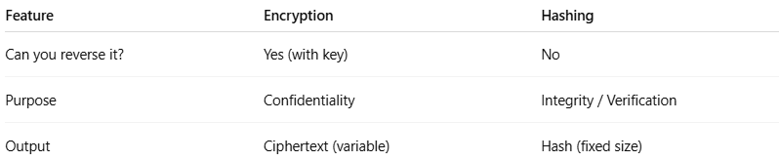
Feature | Encryption | Hashing
Can you reverse it? | Yes (with key) | No
Purpose | Confidentiality | Integrity / Verification
Output | Ciphertext (variable) | Hash (fixed size)
Real-life analogy
Imagine shredding a paper document into tiny pieces and gluing them into a pattern. You can verify it came from the original by comparing patterns, but you can’t reconstruct the original paper.

How hashing protects passwords
# Source: Chatgpt (GPT-5-Mini) at [1/20/2026]
Problem
You don’t want to store your actual password in a website database because if hackers steal it, they get your password.

How hashing protects passwords
- You create a password
Example: MySecret123
- The website hashes it using a hash function (like SHA-256):
- MySecret123 → SHA-256 → e99a18c428cb38d5f260853678922e03
- The website stores the hash (e99a18c428cb38d5f260853678922e03) instead of your password.

When you log in
- You enter your password: MySecret123
- The website hashes it again:
- MySecret123 → SHA-256 → e99a18c428cb38d5f260853678922e03
- The website compares this new hash with the stored hash.
- If they match ✅ → login successful
- If not ❌ → login denied

Why this protects data integrity
- Even if hackers steal the database, they only get the hashes, not the actual passwords.
- Hashes are one-way, so they cannot reverse it to find your password.
- Any tiny change in the password will completely change the hash, so it’s easy to detect tampering.

Extra security
- Websites often add a salt (random value) to make each hash unique, even if two users have the same password:
- MySecret123 + random_salt → SHA-256 → unique_hash

✅ In short:
Hashing protects passwords because the real password is never stored, and any tampering will produce a completely different hash.

random_salt
# Source: Chatgpt (GPT-5-Mini) at [1/20/2026]
A random salt is a random piece of data added to a password before hashing to make the resulting hash unique, even if two people have the same password.

Why we need salt
Without a salt:
Password | SHA-256 Hash
password123 | ef92b778...
password123 | ef92b778...
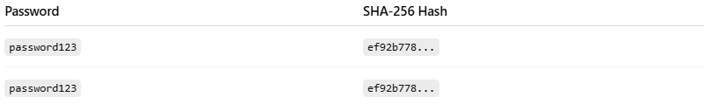
✅ Problem: Two users with the same password will have the same hash, making it easier for hackers to guess passwords using precomputed tables (rainbow tables).
With a random salt:
Password + Salt | SHA-256 Hash
password123+X1a9 | a5c3f92d...
password123+G7b2 | f1b8e72a...
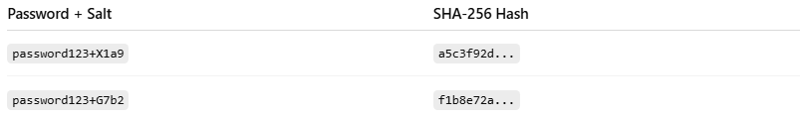
Now even though the password is the same, the hashes are completely different.

How it works
- Generate a random salt:
Example: X1a9
- Combine it with the password:
- password123 + X1a9
- Hash the combined value:
- SHA-256(password123 + X1a9) → a5c3f92d...
- Store both the hash and the salt in the database.
  - When the user logs in, the system adds the same salt to the entered password and hashes it again to check.

Why salt improves security
- Makes rainbow table attacks useless
- Ensures unique hashes for identical passwords
- Protects multiple users’ passwords even if they are the same

💡 Analogy:
Think of a salt as adding a secret ingredient to your cookie recipe. Even if two people bake the same cookie, adding different secret ingredients makes each cookie unique.

